**How to configure yum for docker:**

Type these commands in your vm:

1. cd /etc/yum.repos.d/

2. vim docker.repo

3. Enter these commands in this editor: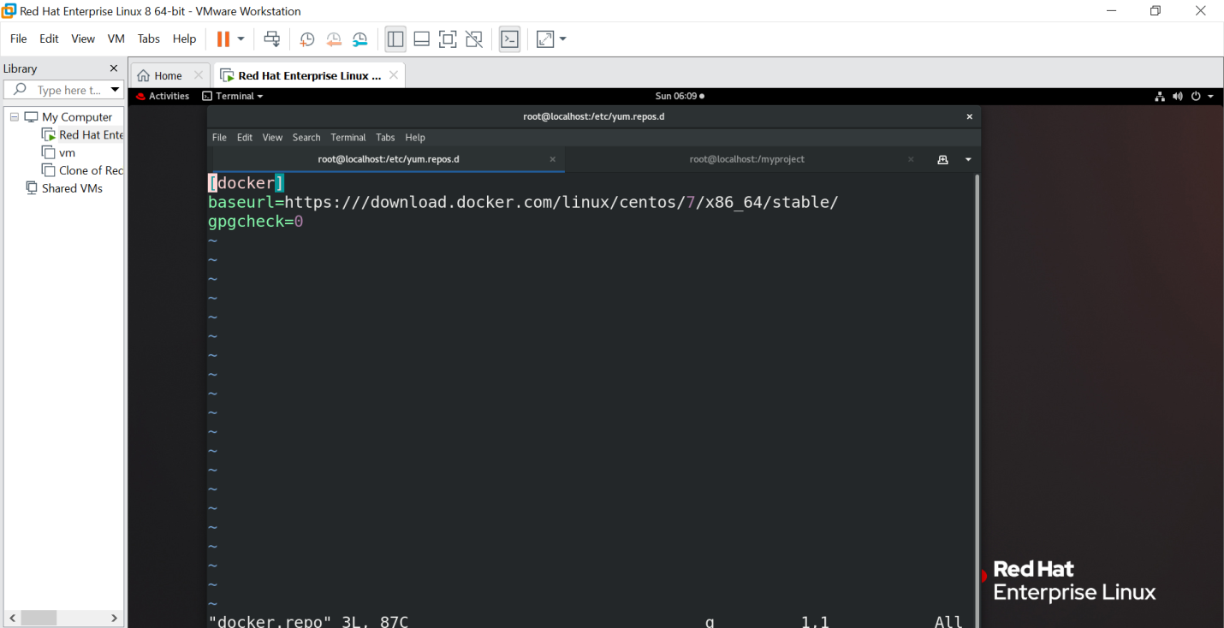

4. Save this file by pressing Esc+shift+:

5. Type wq for saving the file.